# 1.Introduction

Nowadays, technology is getting advanced which are making people life easier. They do not want any stress. Identifying the problems, I have found that they are getting trouble in finding the parking space for their vehicle and some of them are getting late in the workstation due to no parking space. After identifying those problems, I have decided to overcome this problem by creating the webpage so they can book the parking space for their vehicle.

## Justification of Project

### Background of Project

Online parking booking system is web page where you can book parking space for your vehicle so that you don’t have to wait or search the space the park your vehicle. And we can also provide your vehicle for services in our linked service workstation in the affordable price.

By, login into our system you can register as a client where we can give you a little bit of discount who work over that place on the daily basis. You do not need to wait and have to take stress for the vehicle security.

User interface is designed very well the client or customer’s do not have to use tutorial for the registration or for the booking. I have used PHP for coding and MY SQL to control the Model.

## Problem Statement

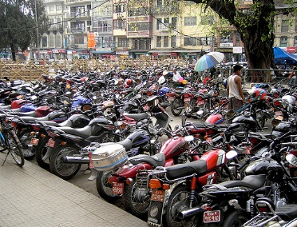

Figure 1:parking problem

Nowadays every individual has their own vehicle. There is a huge problem for people to park their vehicle and wait or search for the space which is totally wasting their time. Sometimes their can be traffic jam due to parking. People are facing this problem in many other countries. As we can see this in the given picture.

## Description of Project

## Features of System

* User can login into the system so we can identify the valid users.
* User can book the parking space from anywhere.
* User can give their vehicle for services near linked workstation
* User can view at which number they can park their vehicle
* User do not have to download application by managing their storage we can direct google and find the web page.

# 2. Project Scope

## 2.1 Scope and Limitation

**Scope**

Online parking system is for parking the vehicle which help gathering information and also keep their vehicle secure. We can register our Number plate, name, address and vehicle brand for parking registration and user can view area of parking of their comfortability.

**Limitation**

Following are the limitation about this system are

Payment is fixed and we will provide you ticket system at which time did you park the vehicle. And user should pay in the parking admin office.

**2.2 Aims and Objective**

The aims of this project are to book area for parking for their vehicle through online website at anytime anywhere. Besides this the main aims are to overcome the number of people waiting and searching for the space and take booking system through online. For the customer’s satisfaction I have decided to book an area through online.

The main objectives of online parking booking are to handle all the information related to particular vehicle. It will keep record of all the information of vehicle in our database system so that in the future if the person lost his vehicle somewhere so that we can track the cars or bike through engine model number through number plate. This system will reduce manual work and will be friendly with the modern technology world.

**3. Development Methodology**

**3.1 Methodology used**

For this project I have used waterfall model which is the first approaches for the software development. In this method we must complete first method to move on another one. Each step is divided which are requirement and analysis, design, implementation, testing and maintenance. Through this step if you have to change something are some mistake are found we have to repeat from first step.

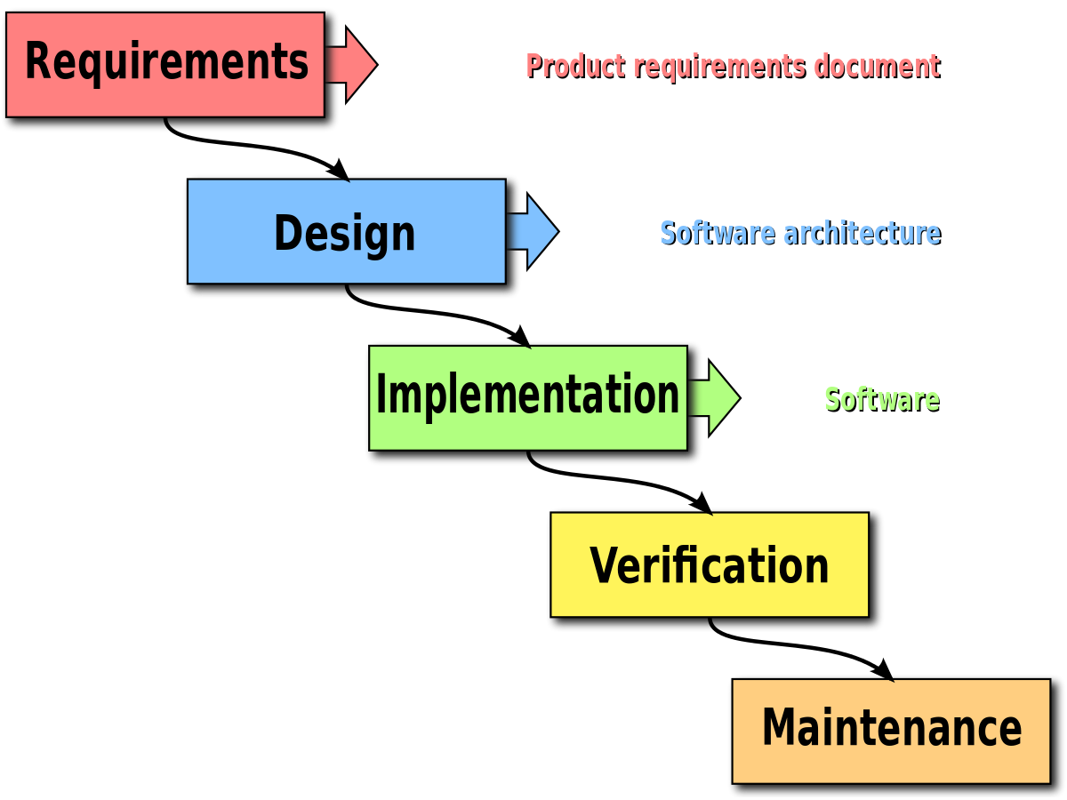

Figure 2:waterfall model

In this method firstly we gather all the requirement in requirement and analysis step through which we can design the project in the second phrase, where we prepare design. Then after that, we perform all the coding park in third step called implementation. The check the correctness we identify verification which is also called unit testing. Second lastly we deploy the software after that maintenance is done.

* 1. **Design Pattern**
* Model view controller is a Software Architectural design pattern
* This is Frequently used design pattern
* Separates system functionality

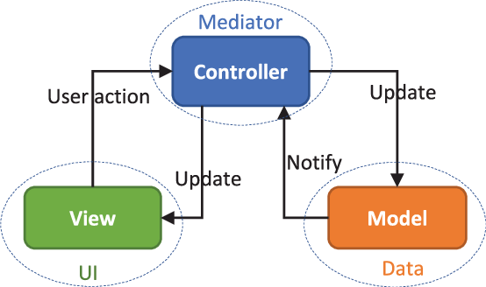

Figure 3:MVC pattern

**Model**

* it is a data related logic
* its interaction with database (CRUD operation)
* related with actual controller where actual database is stored.
* Depending on framework it can sometimes view the update.

**View**

* this is what end user sees called user interface.
* And it communicates with the controller.
* It can be passed dynamic values.

**Controller**

* It receives the user input
* It processes the user request
* It gets main data from the model
* Passes data to the view.

## 3.3 System Architecture

it is a conceptual model that describe the structure, behavior and view of the system which defines the representation of overall system. Here I have used 3 tier system architecture.

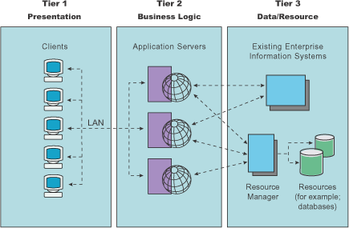

Figure 4:system architecture

# 4. Work breakdown structure (WBS) /Scheduling

## 4.1 Work Breakdown Structure

Breaking down the large project into the small part to manage easily. And this process is used by manager to execute the project.

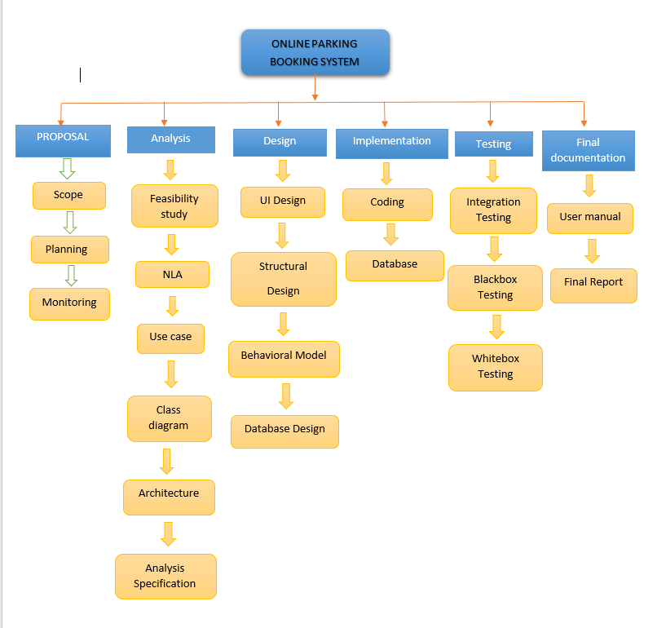

Figure 5:WBS

## 4.2 Milestones

|  |  |
| --- | --- |
| **Milestones** | **Date** |
| **Project Management**  Scope  Planning  Monitoring | 3/25/19 to 3/30/19  4/1/19 to 4/5/19  4/6/19 to 4/9/19 |
| **Analysis**  Feasibility Study  NLA  Use Case  Class Diagram  Architecture  Analysis Specification | 4/10/19 to 4/16/19  4/17/19 to 4/20/19  4/21/19 to 4/23/19  4/24/19 to 4/27/19  4/28/19 to 5/3/19  5/4/19 to 5/8/19 |
| **Design**  UI Design  Structural Design  Behavioral Model  Database Design | 5/9/19 to 5/22/19  5/23/19 to 5/24/19  5/25/19 to 5/28/19  5/29/19 to 6/3/19 |
| **Implementation**  Coding  Database | 6/4/19 to 6/18/19  6/19/19 to 6/19/19 |
| **Testing**  Unit Testing  Integration Testing  Blackbox Testing  Whitebox Testing | 6/27/19 to 6/29/19  6/30/19 to 7/1/19  7/2/19 to 7/2/19  7/3/19 to 7/3/19 |
| **Deployment**  User Training  Final Report | 7/4/19 to 7/10/19  7/11/19 to 7/12/19 |

### Description of Milestones

**Project Management:**

I allocate total 16 days for this task i.e. is 6 days for Scope, 5 days for Planning, 4 days for Monitoring.

**Analysis**

I allocate total 29 days for this task i.e. 7 days for Feasibility Study, 3 days for Use case diagram, 4 days for Class Diagram, 5 days for Analysis Specification, 4 days for NLA and 6 days for architecture.

**Design**

I allocate total 26 days for this task i.e. 2 days for Structural design, 4 days for Behavioral model, 14 days for UI design, 6 days for database design.

**Implementation**

I allocate total 23 days for this task i.e. 8 days for database build and 15 days for coding.

**Testing**

I allocate total 7 days for this task i.e. 3 days for unit testing 2 days for integration testing, 1 days for black box testing and 1 days for white box testing.

**Deployment**

I allocate total 9 days for this task i.e. 7 days for user manual and 2 days for Final Report.

## 4.3 Scheduling / Gantt Chart

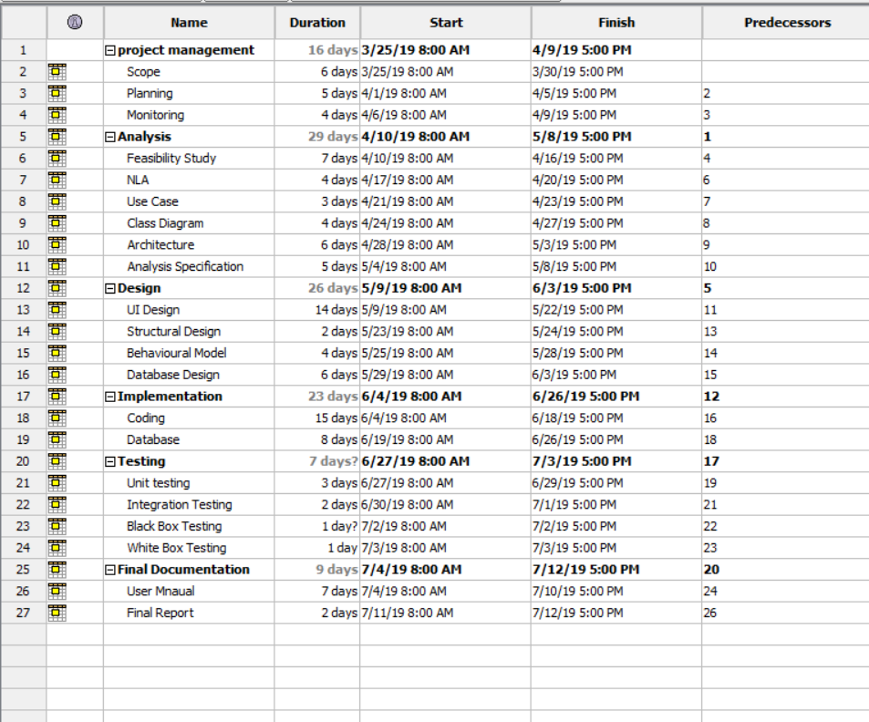

Figure 6:days divided for task

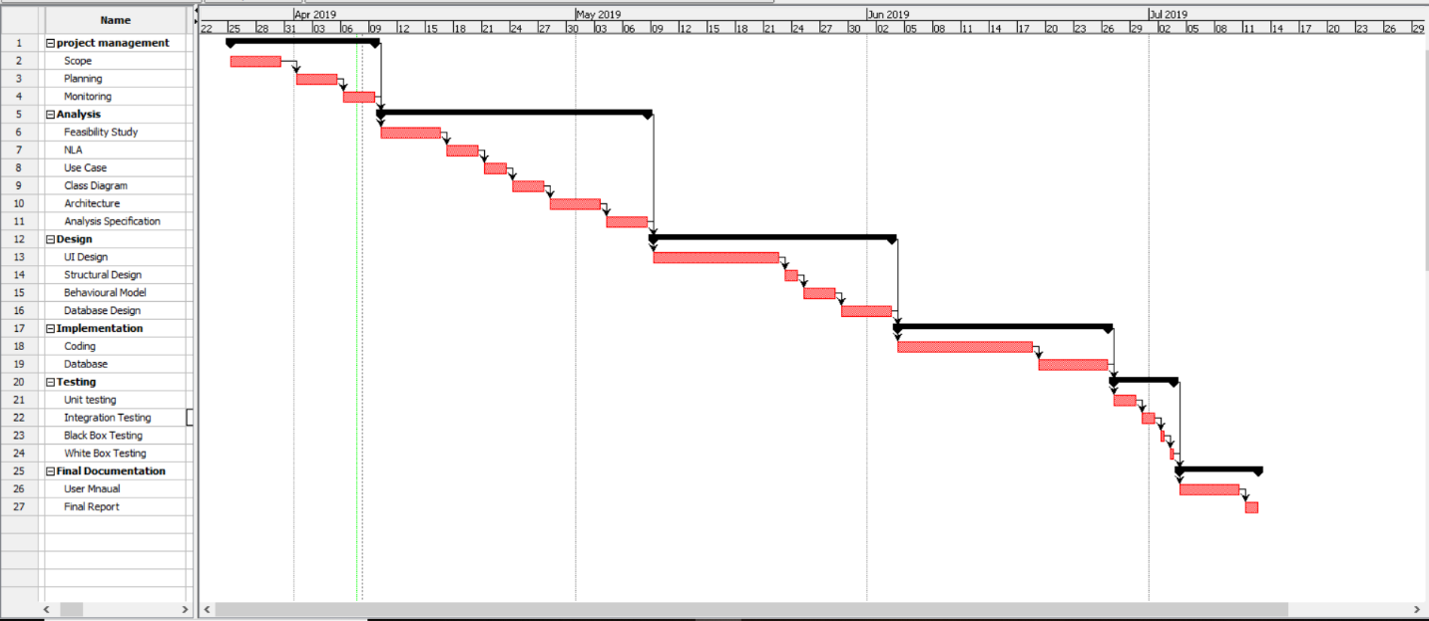

Figure 7:gantt chart for online parking book

# 5. Risk Management

Risk management is about analyzing the risk about Online Parking Booking System. It is the part of planning to identify the risk in the project and to improve those upcoming problem.

The following are the ways to manage the risk management are:

* **Accept**
* **Avoid**
* **Transfer**
* **Mitigate**
* **Exploit**

**Impact = Likelihood * Consequence**

Risk Likelihood values are shown as follows

|  |  |
| --- | --- |
| Likelihood | Value |
| Low | A |
| Medium | B |
| High | C |

* Risk Consequence values are shown below

|  |  |
| --- | --- |
| Consequence | Value |
| Very low | A+ |
| Low | A |
| Medium | B |
| High | C |
| Very High | D |

Risk Consequence values are shown below

|  |  |  |  |  |  |
| --- | --- | --- | --- | --- | --- |
| S. No | Risks | Likelihood | Consequences | Impact | Solution |
| 1 | Insufficient resources | B | B | C | All required resources for the project should be collected. |
| 2 | Hard disk crash | A | C | d | Keep backup of all data |
| 3 | unsatisfaction | C | C | D | Meet all the requirement and use easy interface |
| 4 | Server Failure | A | A+ | B | Server should be maintain in time to time |

# 6. Configuration management

This term refers to track the system related information. This involves practices of processing system systematically with system update while maintaining the system integrity. To get the better result of the system, config should be implement with the details and procedures to handles the system version. This will control software tools which helps in managing main code for the teams.

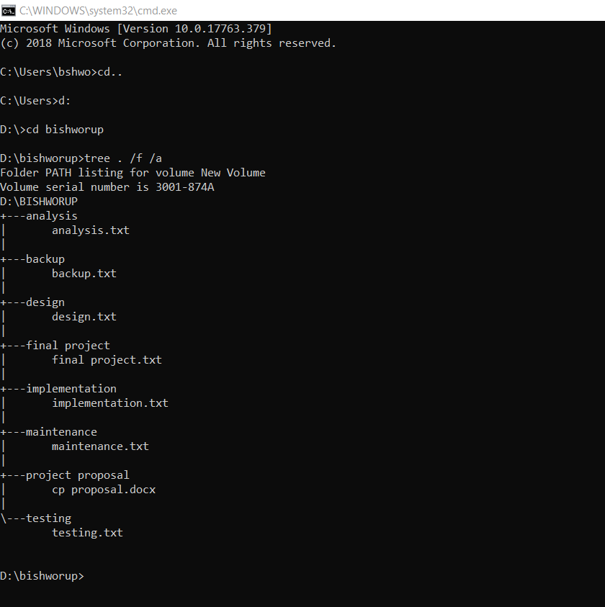

Figure 8:tree config system

# 7. conclusion

In this proposal, I have given the information on how I am going to work in the project of online parking booking system. I have provided list of features, aims, objective design pattern that I am going while working on my project. To manage quality of the product I have insert the Gantt chart to ensure the time interval that will take in making this project.